Be a Tutee for the Peer Tutoring Program!

Do you have a problem with your class? Don’t worry about your problems with classes. Tutors are waiting for you!

About Peer Tutoring

The Faculty of Liberal Education of Seoul National University provides a Peer Tutoring Program every year in order to supplement freshmen students’ learning during their first semester at college. Tutees of this program will be aided directly by outstanding senior students who have had personal experience going through the same difficulties while taking general education courses at SNU. If you expect that you’ll need help with general education courses in Korea or in English during the first semester, don’t miss this great opportunity to learn from the best, and apply as a tutee!

**Be a Tutee for the Peer Tutoring Program!**

Tutee's Benefits

Tutees will receive personal tutoring twice a week throughout the semester from tutors who have been chosen through a rigorous and competitive selection process.

Eligible Students

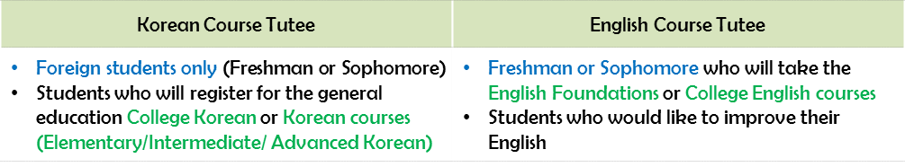

**| Apply as a Tutee …**

1. Visit our website (http://gepeertutoring.snu.ac.kr)

2. Create a user ID and password (Available Members Only)

3. Log in

4. Enter the 'Application' and 'Apply' Menu(신청하기 written in Korean)

5. Click the "TUTEE" button and fill in a 'Tutoring Service Request Form'

6. Finish

**| Orientation**    Sep 12, 2012 (Wed)  17:00 (Building 61, Room 320)

* Participation in this orientation is absolutely mandatory for all tutees

**| Contact** peertutoring2011@gmail.com

**General Education Peer Tutoring Program**

**Faculty of Liberal Education**

**Seoul National University**

Application Process